**ON**

**“ EVOLVE - TRAINING AND PLACEMENT SYSTEM ”**

**Submitted to**

## SAVITRIBAI PHULE PUNE UNIVERSITY

**In Partial Fulfillment of the Requirement for the Award of**

## THIRD YEAR ENGINEERING IN COMPUTER ENGINEERING

### BY

**Ashish Jadhav 24**

#### UNDER THE GUIDANCE OF PROF. D. S. Sharma



**DEPARTMENT OF COMPUTER ENGINEERING**

### Trinity Academy of Engineering, Pune.

**2024-2025**

**AFFILIATED TO**



## TRINITY ACADEMY OF ENGINEERING Department of Computer Engineering



# CERTIFICATE

This is certify that the project entitled

**“ EVOLVE - TRAINING AND PLACEMENT SYSTEM “**

submitted by

#### Name- Ashish Jadhav ROLL NO. - 24

is a record of bonafide work carried out by him, in the partial fulfilment of the requirement for the award of Degree of Bachelor of Engineering (Computer Engi- neering) at Trinity Academy of Engg., Pune under the Savitribai Phule Pune University. This work is done during year 2024-2025, under our guidance.

#### Date: 04 / 04 / 2025

**(Prof. D.S. Sharma) (Prof. B.R. Devhare)**

#### Internal Mentor Internship Coordinator

**(Prof. R.B. Lagdive) (Dr. Rupesh Patil)**

#### HOD, Computer Department Principal

——————————————————————————————————

This project report has been examined by us as per the Savitribai Phule Pune Uni versity requirements at Trinity Academy of Engineering, Pune-48 on —————–.

#### Internal Mentor External Mentor

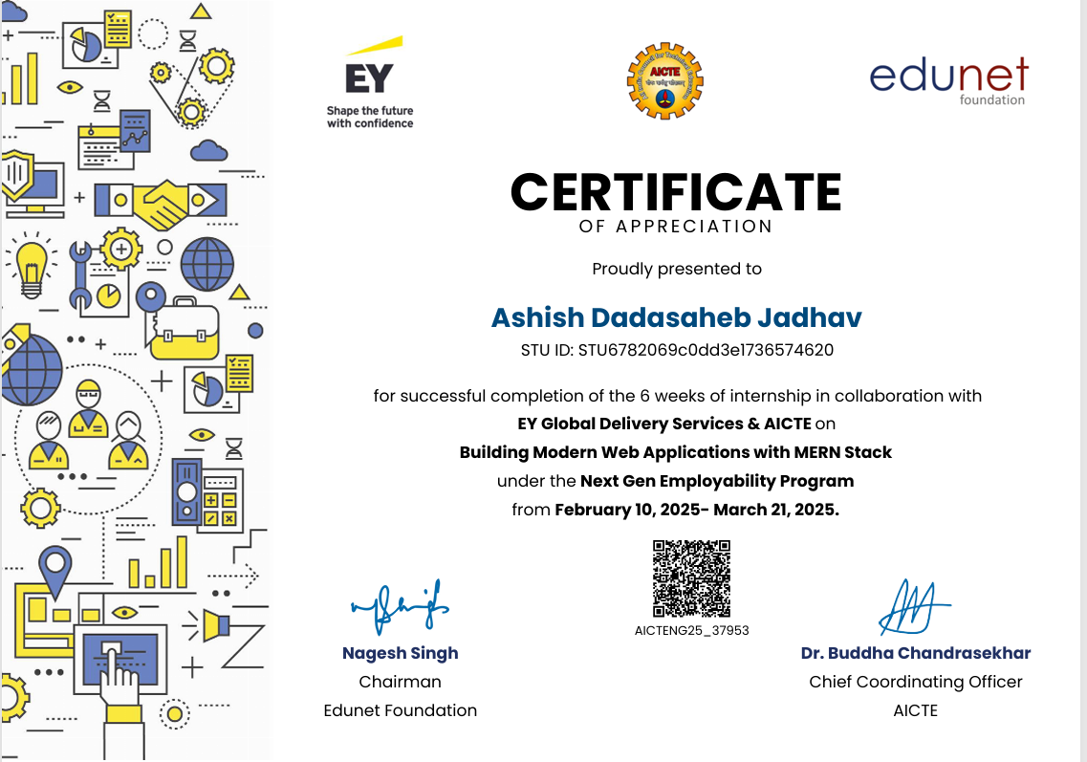

**Acknowledgements**

I would like to acknowledge all the teachers and friends who helped and assisted me throughout my Internship work.

First of all, I would like to thank my respected guide **Ms. D.S. Sharma** for his time-to-time guidance and encouragement. This work would not have been possible without their enthusiastic response, in sight, and new ideas from him. I am thankful to **Mr.B.R. Devhare,** Internship Co-ordinator for timely help and valuable suggestions.

Furthermore, I would like to thank respected **Mr.R.B. Lagdive,** Head of Department and **Dr. R. J. Patil**, Principal for the continuous support during my Seminar work. I am also grateful to all the faculty members of Trinity Academy of Engineering, Pune for their support and cooperation. I would like to thank my lovely parent for time-to-time support and inspiration, and I would like to thank all my friends for their suggestions and support. The acknowledgment would be incomplete without mention of the blessing of the almighty, which helped me in keeping high morale during the difficult period.

**Ashish Jadhav**

## ABSTRACT

Evolve is a comprehensive web-based Training and Placement System designed to streamline the interaction between students, class teachers, and the Training & Placement Cell. The system consists of three integrated modules, each tailored to meet the specific needs of its users.

The Student Module enables students to manage their academic journey effectively by providing access to features such as self-attendance marking, training resources, and real-time updates about placement drives. This empowers students to stay informed and actively participate in placement-related activities. The Class Teacher Module focuses on student data management, allowing teachers to oversee student records, communicate important information, and share placement drive details efficiently. This module ensures smooth coordination between faculty and students, enhancing academic and career guidance.

The Training and Placement Cell Module is dedicated to managing the overall training and placement activities. It provides tools for monitoring student attendance during training sessions, uploading relevant placement and training resources, and organizing recruitment drives. This module serves as the backbone of the system, ensuring effective planning and execution of placement activities. Evolve aims to automate and simplify the traditional training and placement process, making it more transparent, accessible, and efficient for all stakeholders involved.

***Keywords -*** *Training and Placement System, Student Module, Class Teacher Module, Placement Drive, Self-Attendance, Data Management, Resource Sharing, T&P Cell, Web-Based Application, E-Governance, Automation, Communication System, Career Guidance, Recruitment Management*

1. Introduction 1

1.1 SECTION NAME . . . . . . . . . . . . . . . . . . . . . . . . . . . 1

1.1.1 SUBSECTION NAME 1 . . . . . . . . . . . . . . . . . . . 1

1.1.2 SUBSECTION NAME 2 . . . . . . . . . . . . . . . . . . . 1

1. Literature Survey 2

2.1 SECTION NAME . . . . . . . . . . . . . . . . . . . . . . . . . . . 2

1. Software Requirements Specification 3

3.1 SECTION NAME . . . . . . . . . . . . . . . . . . . . . . . . . . . 3

3.1.1 SUBSECTION NAME . . . . . . . . . . . . . . . . . . . . 3

1. System Design 4

4.1 SECTION NAME . . . . . . . . . . . . . . . . . . . . . . . . . . . 4

1. System Testing 5

5.1 Test Cases and Test Results . . . . . . . . . . . . . . . . . . . . . . 5

1. Project Planning 6

6.1 SECTION 1 . . . . . . . . . . . . . . . . . . . . . . . . . . . . . . 6

1. Implementation 7
2. Screenshots of Project 8

8.1 SECTION NAME . . . . . . . . . . . . . . . . . . . . . . . . . . . 8

1. Conclusion and Future Scope 10
   1. Conclusion 10
   2. Future Scope 10

References 10

|  |  |  |  |
| --- | --- | --- | --- |
| 1.1 | **IMAGE CAPTION** | . . . . . . . . . . . . . . . . . . . . . . . . . | 1 |
| 7.1 | **IMAGE CAPTION** | . . . . . . . . . . . . . . . . . . . . . . . . . | 7 |

# Introduction

**1.1 Need**

Training and placement is one of the most vital aspects of a student’s academic journey, especially in professional courses like engineering and management. It serves as a bridge between academic life and the professional world. Efficient management of training schedules, student performance, and placement drives is crucial for institutions aiming to provide better career opportunities for their students. However, traditional methods of managing training and placement activities often involve paperwork, manual coordination, and communication delays, leading to inefficiency and confusion.To address these challenges, Evolve – a web-based Training and Placement Management System – has been developed. The system aims to bring digital transformation to the existing processes by automating and organizing key activities involved in student training and placement preparation. Evolve provides a structured platform that connects students, class teachers, and the Training & Placement (T&P) Cell through three dedicated modules.

The Student Module allows students to mark self-attendance, access training materials, and stay updated with placement drive schedules and eligibility criteria. This empowers students to manage their own preparation and stay engaged throughout the process.The Class Teacher Module is designed to manage student academic and placement data. Teachers can update and track student information, share important announcements, and forward placement drive details to relevant students efficiently.The T&P Cell Module focuses on handling the overall training and placement process, including uploading training content, managing company interactions, organizing placement drives, and monitoring student participation.

By digitizing these processes, Evolve eliminates manual work, enhances communication, and ensures a smooth flow of information between all stakeholders. It not only saves time and effort but also increases transparency, accountability, and student involvement.

In today’s fast-paced academic environment, a smart and centralized training and placement system like Evolve is not just an advantage, but a necessity for institutions aiming to ensure better career outcomes for their students.

**1.2 Motivation**

**1. Inefficiency of Traditional Systems**

Traditional training and placement activities are managed manually using paperwork, notice boards, and emails. This often leads to miscommunication, data loss, delays in sharing updates, and a lack of centralized control. We identified the need for a system that could simplify and automate these processes.

**2. Lack of Centralized Platform**

Currently, there is no unified platform that connects students, class teachers, and the T&P Cell. Each stakeholder works in isolation, which causes delays in updates and makes it difficult to track student engagement and performance. A centralized platform like Evolve bridges this gap effectively.

**3. Empowering Students**

Students need a system where they can actively participate in their placement preparation. Features like self-attendance, access to training resources, and timely notifications help students become more responsible, self-driven, and better prepared for interviews and placement drives.

**4. Ease for Class Teachers**

Class teachers are responsible for managing student data, updating records, and forwarding placement information. With a large number of students, this becomes time-consuming. Our system reduces their workload by allowing them to perform these tasks digitally and more efficiently.

**5. Improving T&P Cell Functionality**

The Training & Placement Cell needs a reliable tool to organize drives, manage training sessions, share resources, and monitor student attendance and performance. The Evolve system provides a structured backend to manage these responsibilities with ease and speed.

**6. Support for Digital Transformation**

In line with the "Digital India" initiative, academic institutions are expected to adopt digital solutions. Evolve helps in transforming manual processes into smart, paperless, and efficient workflows.

**7. Personal Experience as Students**

As students, we have faced challenges in receiving timely information, tracking our attendance, and accessing learning materials. These personal experiences motivated us to design a system that would not only solve our problems but also help future students.

* 1. **Basic Concept**

The Evolve – Training and Placement System is a web-based platform designed to manage and streamline the various processes involved in student training and campus placements. It is built on the idea of bringing together all the key stakeholders—students, class teachers, and the Training & Placement Cell—into one unified system to improve communication, coordination, and efficiency.

The system is divided into three main modules, each with its own functionality:

**1. Student Module**

Allows students to mark their own attendance for training sessions.

Provides access to training materials, such as aptitude, technical, and soft skills resources. Notifies students about upcoming placement drives, company details, eligibility criteria, and schedules. Helps students stay updated and actively engaged in the placement preparation process.

**2. Class Teacher Module**

Enables teachers to manage student data, including academic records, contact details, and placement status.Teachers can send announcements or messages regarding training sessions or placement-related events.Helps in monitoring student participation and updating the T&P Cell with relevant information.

**3. Training and Placement Cell Module**

Manages company profiles, placement drive schedules, and training programs.Uploads and shares placement-related documents, preparation tips, and company-specific materials.Tracks student attendance and performance during training and placement activities.Provides analytics and reports for better decision-making and planning.

# Literature Survey

Shukla et al. (2024) introduced a Web-Based Placement Management System aimed at streamlining campus recruitment processes. This system allows students to create detailed profiles, submit job applications, and receive automated notifications about interview schedules and outcomes. By integrating advanced data analytics, the platform offers personalized job recommendations and real-time tracking of application statuses. The system enhances communication between students, educational institutions, and employers, leading to improved administrative efficiency and better decision-making. Overall, it simplifies the logistical aspects of campus recruitment and enhances the student experience, making graduates more competitive in the job market [1].

Lamin et al. (2024) focused on improving the management of student internships at Universiti Poly-Tech Malaysia through the development of the Internship Placement Management System (IPMS). The system encompasses modules for managing user information, processing internship applications, monitoring student progress, assigning academic supervisors, evaluating student performance, and generating reports. By systematically handling these processes, IPMS enhances efficiency and provides a better experience for students and coordinators. The implementation of IPMS ensures accurate tracking and management of the entire internship process, contributing to improved organizational efficiency [2].

Rizvi et al. (2021) developed a Placement Management System to automate the placement activities within educational institutions. The system reduces manual errors and enhances communication among stakeholders by providing a centralized platform for managing student data, job postings, and application processes. It includes features such as automated notifications, interview scheduling, and performance tracking. The implementation of this system leads to improved efficiency in placement activities and better coordination between students, faculty, and recruiters [3].

Gupta et al. (2019) proposed a Recruitment System with Placement Prediction that leverages data analytics to match candidates with suitable job profiles. The system collects and analyzes data on student performance, skills, and preferences to predict the likelihood of successful placement in various job roles. This predictive capability enables recruiters to make informed decisions and enhances the efficiency of the recruitment process. The system also provides feedback to students, helping them understand their strengths and areas for improvement [4].

Padwal et al. (2022) introduced an E-Training and Placement Management System aimed at automating conventional procedures to improve accessibility and coordination among students, faculty, and recruiters. The system offers a platform for managing training sessions, placement drives, and related activities. It includes features such as online registration, attendance tracking, resource sharing, and performance evaluation. By digitizing these processes, the system reduces administrative workload and enhances the overall efficiency of training and placement activities [5].

Hanshida et al. (2022) developed a system facilitating seamless communication between students and employers, ensuring timely updates on placement opportunities. The system allows students to access information about job openings, submit applications, and receive notifications about interview schedules. Employers can post job vacancies, review applications, and communicate with potential candidates. The system enhances the transparency and efficiency of the campus recruitment process, benefiting both students and employers [6].

Swathi et al. (2018) designed a Training and Placement Cell Application to monitor student progress and manage placement activities effectively. The application provides a platform for students to update their profiles, access training materials, and apply for job opportunities. It also allows the placement cell to track student performance, schedule training sessions, and coordinate with recruiters. The application improves the organization and efficiency of training and placement activities within educational institutions [7].

Hitachi and Texans Credit Union have utilized AI to enhance employee onboarding processes, resulting in significant time savings and reduced HR involvement. AI digital assistants and robotic process automation streamline tasks such as paperwork, system access, and addressing new-hire questions. These implementations have led to more efficient onboarding experiences and allow HR departments to focus on more strategic tasks [8].

Companies like Johnson & Johnson and DHL are leveraging AI-driven processes to assess worker skills, identify training needs, and support internal hiring. AI facilitates the creation of personalized training materials and simulations, allowing employees to practice and improve their skills in safe environments. These initiatives help organizations address skills gaps, retain staff, and enhance workforce capabilities [9].

Patil et al. (2017) focused on automating traditional training and placement management systems to enhance efficiency and reduce manual errors. The proposed system digitizes processes such as student registration, job application, interview scheduling, and performance tracking. By automating these tasks, the system minimizes administrative workload and improves the accuracy and speed of placement activities [10].

Singh et al. (2023) developed a Training and Placement Cell Automation system aimed at minimizing manual work and enhancing optimization, abstraction, and security within the training and placement units of educational institutions. This web-based application allows authorized personnel to access and manage student information securely through login credentials. Students can fill out a registration form, with their information stored for future reference, eliminating the need for repetitive data entry. The system enables administrative staff to manage student details related to placements, generate candidate lists, and search for specific information. By automating these processes, the system reduces manual workload, enhances efficiency, and facilitates quick access to placement-related activities, contributing to the full IT deployment of the institution [11].

Addanki et al. (2019) introduced Placeto, a reinforcement learning approach designed to efficiently determine device placements for distributed neural network training. Unlike prior methods that focus on specific computation graphs, Placeto learns generalizable device placement policies applicable to various graphs. The approach involves representing the policy as performing iterative placement improvements and utilizing graph embeddings to capture relevant structural information without relying on node labels. This methodology enables Placeto to train efficiently and generalize to unseen graphs, requiring significantly fewer training steps to find optimized placements compared to previous approaches. The study demonstrates Placeto's ability to learn generalizable placement policies for families of graphs, eliminating the need for retraining for new graphs within the same family [12].

Mirhoseini et al. (2017) proposed a method for optimizing device placement in TensorFlow computational graphs using reinforcement learning. The approach employs a sequence-to-sequence model to predict optimal placements of computational operations across available devices. The execution time of the predicted placements serves as the reward signal to optimize the model parameters. The study's results indicate that, on models like Inception-V3 for ImageNet classification and RNN LSTM for language modeling and neural machine translation, the learned placements outperform hand-crafted heuristics and traditional algorithmic methods, showcasing the potential of reinforcement learning in automating device placement decisions [13].

Yan et al. (2022) provided a comprehensive survey on the application of machine learning techniques to placement and routing tasks in chip design. The paper introduces the fundamentals of placement and routing, reviews classic learning-free solvers, and discusses recent advancements in machine learning applications for these tasks. The authors highlight the challenges and opportunities in integrating machine learning methodologies into chip design, emphasizing the potential for data-driven approaches to enhance scalability and reduce reliance on expert knowledge. The survey serves as a methodological overview, guiding future research in this domain [14].

Shua et al. (2017) developed an application titled An Automated Solution to Training and Placement Cell Activities, aimed at streamlining the management of student information related to placements. This application enables placement officers to efficiently handle student data, allowing students to upload personal and educational information in the form of resumes. A key feature is the one-time registration, reducing redundancy in data entry. The system supports the generation of candidate lists based on specific queries and facilitates quick access to placement-related activities. By automating these processes, the application enhances efficiency and reduces manual workload in training and placement cells [15].

A recent article discusses how AI technology is significantly aiding small and medium-sized enterprises (SMEs) in automating administrative tasks, leading to improved efficiency and reduced paperwork. Employment Hero, an employment management platform, exemplifies this by streamlining routine processes such as recruitment and payroll, allowing staff to focus on more meaningful work. The use of AI not only boosts productivity and engagement but also supports flexible and hybrid work practices. By consolidating various business functions into one platform, Employment Hero reduces the complexity and cost of using multiple software systems, fostering deeper, uninterrupted work and increasing job satisfaction among employees [16].

An article highlights how companies like Hitachi and Texans Credit Union are utilizing AI to enhance employee onboarding processes, resulting in significant time savings and reduced HR involvement. AI digital assistants and robotic process automation streamline tasks such as paperwork, system access, and addressing new-hire questions. These implementations have led to more efficient onboarding experiences, allowing HR departments to focus on more strategic tasks. The article advises companies to identify their unique challenges, conduct focused research, and custom-build AI systems to meet their specific needs, ultimately creating a smoother and more engaging experience for new employees [17].

Goldie and Mirhoseini (2020) explored the application of deep reinforcement learning to placement optimization problems in systems and chip design. The paper motivates the use of reinforcement learning for placement tasks, provides an overview of deep reinforcement learning, and formulates the placement problem within this framework. The authors demonstrate how policy gradient optimization can solve the placement problem and share insights gained from training deep reinforcement learning policies across various placement optimization scenarios. The study underscores the potential of reinforcement learning in automating and improving placement decisions in complex design environments [18].

​

1. **Implementation**

​

**4. Software Requirements Specification**

**4.1 Introduction**

* **Purpose**  
  The purpose of this system is to automate and streamline the training and placement process for students, class teachers, and the Training & Placement (T&P) department. It enables student self-attendance, access to placement resources, and drive information. Teachers can manage student data and communicate updates. T&P officers can oversee training activities, placements, and attendance tracking.
* **Scope**  
  The system consists of three modules:
  1. **Student Module** – Allows students to mark self-attendance, view training/placement resources, and receive updates on placement drives.
  2. **Class Teacher Module** – Enables data management, student communication, and drive notifications.
  3. **T&P Module** – Manages company drives, training resources, student placement status, and analytics.
* **Definitions, Acronyms, and Abbreviations**
  1. SRS – Software Requirements Specification
  2. T&P – Training and Placement
  3. UI – User Interface
  4. DB – Database
  5. CRUD – Create, Read, Update, Delete
* **References**
  1. IEEE 830-1998 (Software Requirements Specification Standard)
* **Overview**  
  This document outlines the functional and non-functional requirements of the "Evolve" Training and Placement System, including system architecture, modules, user interaction, and data handling.

**4.2 Overall Description**

* **Product Perspective**
  1. Designed for educational institutions with centralized training and placement functions.
  2. Integrates with existing student databases or academic management systems.
  3. Web-based, mobile-compatible application with responsive design.
* **Product Functions**
  1. Student self-attendance and profile management.
  2. Class teacher interface for communication and data updates.
  3. T&P dashboard for training session updates, company drives, and performance tracking.
  4. Notifications and alerts for all modules.
  5. Downloadable reports and data exports.

**Functional Requirements**

* **FR1**: The system shall allow students to mark self-attendance securely.
* **FR2**: The system shall allow class teachers to manage and edit student profiles.
* **FR3**: The system shall notify students about upcoming placement drives.
* **FR4**: The system shall allow T&P officers to upload training materials and company data.
* **FR5**: The system shall generate attendance and placement status reports.
* **FR6**: The system shall support role-based access (student, teacher, T&P officer).
* **FR7**: The system shall maintain a history of drives attended and placed students.

**Non-Functional Requirements**

* **NFR1**: The system shall respond to user actions within 3 seconds.
* **NFR2**: The system shall support at least 500 concurrent users.
* **NFR3**: The system shall implement secure login and encrypted data storage.
* **NFR4**: The system shall be compatible with mobile, tablet, and desktop interfaces.
* **NFR5**: The system shall be developed using secure coding practices and comply with data protection laws.
* **NFR6**: The UI shall be user-friendly, intuitive, and multilingual (if needed).

**5. System Architecture**

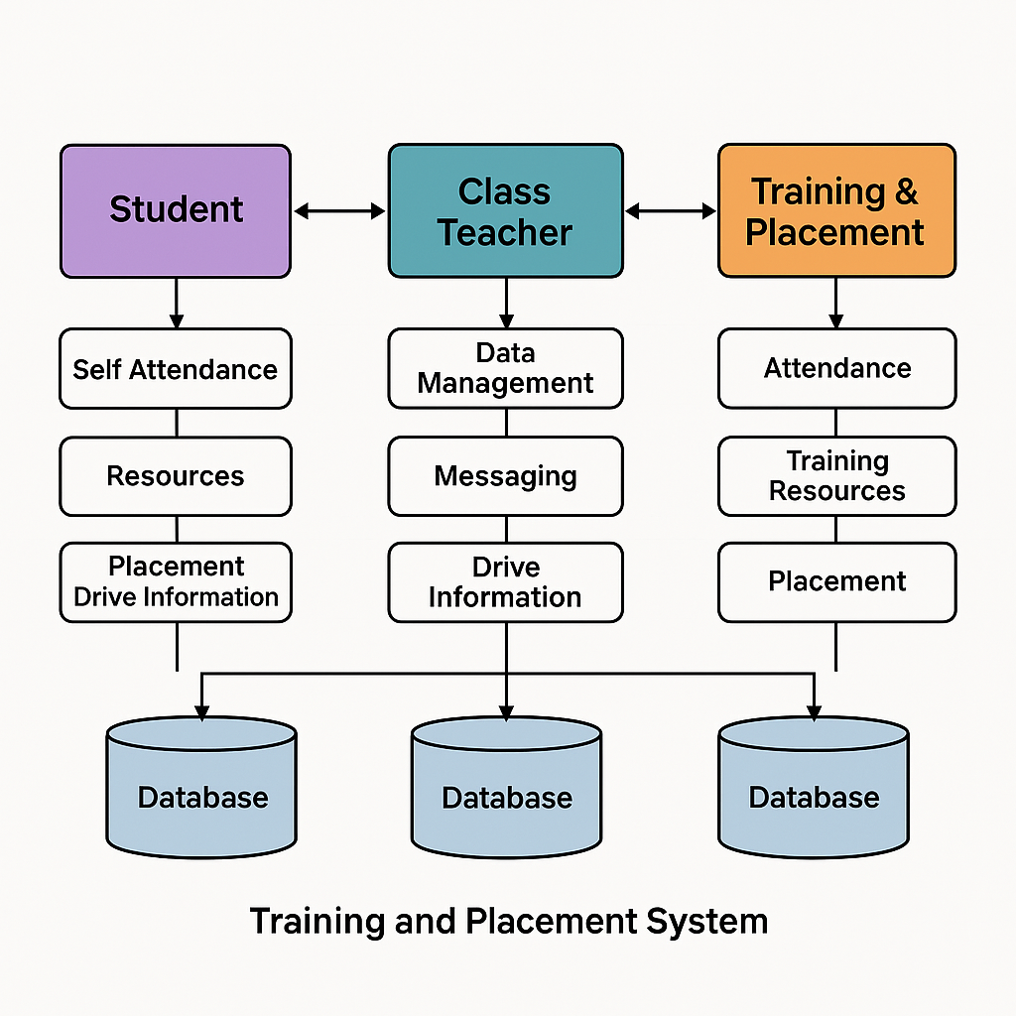

# 6. Methodology

# 6.1. Requirement Analysis

# Gathered requirements from stakeholders – students, class teachers, and training & placement officers.

# Identified common functionalities and custom needs of each user group.

# Prioritized features based on user feedback and institutional objectives.

# 6.2. System Design

# Created system architecture diagrams to define module interactions.

# Database schemas were designed to handle user profiles, placement events, attendance, and training content.

# Each module (Student, Class Teacher, TPO) was designed with specific roles and access levels.

# 6.3. Technology Stack Selection

# Frontend: React.js – for dynamic user interfaces.

# Backend: Node.js with Express.js – to build RESTful APIs.

# Database: MongoDB – for flexible document-based data storage.

# Authentication: JWT (JSON Web Tokens) – for secure login and role-based access control.

# 6.4. Module Development

# Student Module: Includes placement info, attendance, resources, and profile management.

# Class Teacher Module: Manages student data, attendance, and progress tracking.

# TPO Module: Handles drive creation, resource upload, and group management.

# 6.5. Testing

# Conducted unit testing for each function.

# Performed integration testing to check module interaction.

# User testing done through pilot runs with real users (students and faculty).

# 6.6. Deployment

# Hosted on cloud-based services (like Render/Heroku).

# Connected to MongoDB Atlas for online database access.

# 6.7. Maintenance & Updates

# Feedback-driven updates were scheduled.

# Bug reports and suggestions collected from users for continuous improvement.

# 7. Advantages , Disadvantages and Applications

# 7.1. Advantages

# Automation of Tasks: Reduces manual workload for teachers and placement officers by automating attendance, data management, and placement tracking.

# Real-Time Updates: Students receive timely notifications about placement drives, improving communication.

# Centralized Platform: All training and placement activities are managed in one system, improving efficiency.

# User-Friendly Interface: Simple UI makes it easy for students, teachers, and T&P officers to use.

# Improved Data Accuracy: Minimizes human errors in record-keeping and enhances reliability.

# Role-Based Access: Ensures data privacy by providing access based on user roles (student, teacher, TPO).

# Scalability: The system can be expanded easily to include more institutions or advanced features.

* **Easy Report Generation**: Automatically generates attendance and placement reports, saving time for staff.

# 7.2. Disadvantages

# Initial Setup Cost: Developing and deploying the system may require time, resources, and infrastructure.

# Internet Dependency: The system requires internet access for full functionality, which may not be available in all regions.

# Maintenance and Updates: Regular maintenance is needed to fix bugs and update features.

# Training Required: Users (especially faculty) may require basic training to effectively use the system.

# Security Risks: If not properly secured, sensitive data could be vulnerable to cyber threats.

# Data Migration Issues: Shifting from an old system to the new one may result in compatibility or data loss issues.

# 7.3. Applications

# Colleges and Universities: For managing student training, placements, and company interactions.

# Polytechnic and Technical Institutes: To track industry visits, internships, and skill development programs.

# Government Skill Development Programs: Can be used in schemes like Skill India or PMKVY to manage training and placement records.

# Corporate Training Institutes: Useful for managing student progress and tracking placement outcomes.

# Online Learning Platforms: Can be integrated with e-learning portals to enhance career support features.

# Vocational Training Centers: Useful for tracking short-term courses and placement outcomes.

# EdTech Platforms: Can integrate this system to offer placement support alongside online courses.

**8. Conclusion and Future Scope**

### 8.1. Conclusion

The *Evolve* Training and Placement System successfully addresses the challenges associated with manual processes in training and placement activities within educational institutions. By automating key tasks such as attendance tracking, placement drive management, communication, and resource sharing, the system enhances efficiency and reduces administrative burden for class teachers and the T&P department.

The modular architecture ensures that each user role—student, class teacher, and T&P officer—has dedicated access to relevant features and data. The platform facilitates real-time updates, centralized data management, and smooth coordination between departments and students. It not only improves transparency in the placement process but also empowers students by giving them control over their own training and placement activities.

Overall, the system provides a user-friendly, secure, and scalable solution that significantly streamlines institutional workflows and contributes to better placement outcomes.

### 8.2. Future Scope

The *Evolve* Training and Placement System has significant potential for future enhancement and scalability. One of the most promising directions is the integration of Artificial Intelligence (AI) and Machine Learning (ML) to predict student placement outcomes based on academic records, skills, and extracurricular activities. This would help students identify suitable career paths and prepare accordingly. A smart resume builder can also be incorporated to assist students in creating professional CVs while performing skill gap analysis to recommend personalized training content.

In addition, the development of a mobile application for both Android and iOS platforms will enhance accessibility, enabling students and faculty to receive real-time notifications and manage tasks more efficiently. Another useful feature could be a company feedback portal where recruiters can share insights about the students they interact with. This feedback can be used to fine-tune training programs and align student skills with industry requirements.

# 9. References

1. Chaurasia, S. (2023). *Student Internship Placement Management System using Python*. International Journal of Research in Science & Engineering, 3(03), 30–49.
2. Shukla, S., Shinde, S.K., Jiwatode, K., & Somvanshi, U. (2024). *A Development of Web Based Placement Management System for Campus Recruitment*. Journal of Advanced Database Management & Systems, 11(03), 20–28.
3. Lamin, N.Z., Wan Jusoh, W.N.A., Mohd Zainudin, A.J., Abd Samad, N.H., & Badari, K.A. (2024). *Optimizing Internship Placement Process: A Study on the Implementation of an Internship Placement Management System (IPMS) at Universiti Poly-Tech Malaysia to Improve Efficiency and Student Experience*. International Journal of Religion, 5(9), 882–895.
4. Rizvi, F.T., Khan, N.A., Upadhyay, S.S., & Suryawanshi, S. (2021). *Placement Management System*. International Journal of Research in Applied Science & Engineering Technology, 9, 69–76.
5. Gupta, S., Hingwala, A., Haryan, Y., & Gharat, S. (2019). *Recruitment System with Placement Prediction*. Proceedings of the International Conference on Artificial Intelligence and Smart Systems, 4(2), 669–673
6. Padwal, S., Ghorpade, S., Patil, P.R., Patil, M., Biraje, S., & Salunkhe, S. (2022). *E-Training and Placement Management System*. International Research Journal of Modern Engineering & Technology Science, 4(6), 4324–4329.
7. Hanshida, P., Pius, S., & Kunhali, Y.M.S.N. (2022). *Placement Management System for Campus Recruitment*. International Journal of Advanced Research in Innovative Ideas in Education, 8, 1710–1715.
8. Swathi, J., PriyaTharsini, K., Janani, S.S., & Chakkaravarthy, G.V. (2018). *Training and Placement Cell Application*. International Research Journal of Engineering Technology, 5(3), 2422–2425.
9. Singh, M., Raj, A., & Tiwari, D. (2023). *Training and Placement Cell Automation*. International Journal of Research in Engineering, Science and Management (IJRESM), 6(7), 165–169.
10. Addanki, R., Mirhoseini, A., et al. (2019). *Placeto: Learning Generalizable Device Placement Algorithms for Distributed Machine Learning*. arXiv preprint.
11. Mirhoseini, A., Pham, H., et al. (2017). *Device Placement Optimization with Reinforcement Learning*. arXiv preprint.
12. Yan, W., Wang, Y., et al. (2022). *Towards Machine Learning for Placement and Routing in Chip Design: A Methodological Overview*. arXiv preprint.
13. Shua, F., Shah, R., & Gupta, S. (2017). *An Automated Solution to Training and Placement Cell Activities*. International Journal on Recent and Innovation Trends in Computing and Communication (IJRITCC), 5(5), 529–533.
14. Mirhoseini, A., et al. (2020). *Placement Optimization with Deep Reinforcement Learning*. arXiv preprint.
15. Thoma, C., et al. (2014). *Automated Operator Placement in Distributed Data Stream Management Systems*. SpringerLink, Lecture Notes in Computer Science, 8725, 255–270.
16. Business Insider. (2025). *Companies Large and Small are Using AI for Employee Onboarding*.
17. The Guardian. (2024). *More Time, Less Tedium: How AI is Helping SMEs to Innovate and Compete*.
18. Financial Times. (2024). *AI Tools to Address Skills Gaps and Retain Staff*.